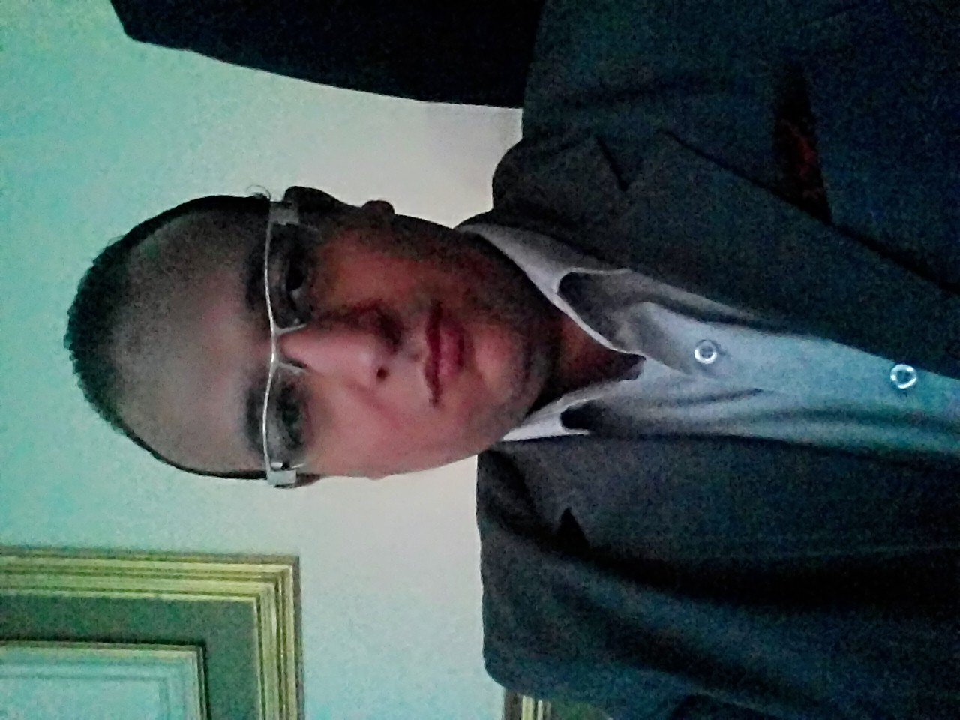
Mahmoud bahaa el dean mousa

Address: 3 Assiut-el waladya el mamal streat

Mobile: (+2) 01009465426
Email: dr.mahmoudbahaa@aun.edu.eg
dr.mahmoudbahaa@med.au.edu.eg

Career Objective

Seeking for a challenging position in a reputable company where my Interpersonal skills and studies background are well developed and utilized.

Training Courses and Certifications

- EDU Egypt program Scholarship from ITI ( Business process ) outsourcing under the supervision of ITI, Infosys and new horizon companies) includes:




- English Skills (Phonetics and Vocabulary).
- Communication skills.
- Presentation skills .
- The problem solving process course.
- Customer Services.
- Computer Skills:

  - MS Office 2003
  - MS Office 2007
  - Typing Master

2-Advanced cardiovascular life support coarse 2016
3-Microsoft Office Outlook 2003 and 2007 & MS Office 2003 and 2007.

LANGUAGE Skills

Arabic | Mother tongue.
English | Very Good Knowledge of both written and spoken.

Education

- B.Sc. – Faculty of medicine from Assiut University.
- M.sc Anesthesia and ICU 2017
- Graduation Year: 2012.
- Graduation grade: Excellent

PERSONAL INFORMATION

Date of Birth : 7 of April 1989.
Marital Status : Single.
Nationality : Egyptian.
Home No : (+2) 088-2160673.

Personal Skills

- Excellent communication (oral and written), interpersonal, organizational, and presentation skills.
- High ability to work under pressure and meeting deadlines.
- Strong analytical, problem solving and decision-making skills.
- Teamwork and mentoring skills, high ability to work individually and within groups.
- High ability to grasp new information and technology in a short period of time.
- Excellent negotiation and speaking skills and ability to make presentation.

Work Experience

- Anaesthesia residency for 3 years.
Demonstrator for one year.
Assistant Lecturer for one year

INTERESTS

* Reading. * Traveling. * Helping others. * Internet Navigation.

Reference:

* Note: References are available upon request.

* The ability, skills, experience and certifications which exist in my curriculum vitae increases and has been updated due to training courses which I join.

"It's really my pleasure to be a member in your teamwork"

